

GlobeTrek Insights: NavigatingGlobalCountryDataWithIBMCognos

TEAMID:NM2023TMID05015

TEAMLEADER:ARNIKAKTEAMMEMBERS: ANUSORNAK

ARAVINTHSARUNKUMARG

TABLEOFCONTENTS



INTRODUCTION

ProjectOverviewPurpose

LITERATURESURVEY

ExistingproblemReferences

ProblemStatementDefinition

IDEATION&PROPOSEDSOLUTION

Ideation&BrainstormingREQUIREMENTANALYSIS

Functionalrequirement

Non-FunctionalrequirementsPROJECTDESIGN

DataFlowDiagrams&UserStoriesSolutionArchitecture

PROJECTPLANNING&SCHEDULING

TechnicalArchitecture

CODING&SOLUTIONING

DatabaseSchema(ifApplicable)PERFORMANCETESTING

8.1PerformaceMetricsRESULTS

9.1

OutputScreenshotsADVANTAGES&DISADVANTAGESCONCLUSION

FUTURESCOPEAPPENDIX

# 1INTRODUCTION

In today's fast-paced and data-driven business landscape,thekeytoachieving optimalmarketing campaign successliesinthestrategicutilizationofdataanalysis.Gonearethedayswhen

marketingdecisionswere basedon intuition or

guesswork;now,the powerof datatogain valuableinsightsintoconsumerbehavior, preferences, andmarkettrends.Leveragingdataanalysishasbecomeafun

damental



tunetheircampaigns,maximizereturnoninvestment,anddeliverprecisely tailored messages to their targetaudience.



Thisintroductionexploresthecriticalroledataanalysisplaysinshapingmarketingcampaigns for

success andoutlinesthetransformativepotentialitholdsforbusiness

esstrivingtoremaincompetitiveinanincreasinglydata-centricworld.

# PROJECTOVERVIEW

Thisprojectfocusesonharnessingthepowerofdataanalysis







vingthebestre



sults.

# PROJECTOBJECTIVE/PURPOSE

Data-DrivenDecisionMaking:

tio



ntodata-backedinsights,enhancingtheoveralleffectivenessofcampaigns.

AudienceSegmentation:

nctgroupsbasedondemographics,behavior,andpreferences,tailoringmarketingeffortsaccordingly.



CampaignOptimization:

Continuouslymonitorandrefinemarketingcampaignsthrough data analysis, ensuring they performattheirpeakandadapttochangingmarketdynamics.

Personalization:

Implementpersonalizedmarketingstrategiesbyanalyzingcustomerdata,creatingamoreengagingandrelevantexperiencefortheaudience.

CostEfficiency:



Perfo



rmanceMetrics:

Developkeyperformanceindicators(KPIs)toassess

me.

# PROJECTMETHODOLOGY

DataCollection:



websiteanalytics,socialmedia,andemailcampaigns.DataAnalysis:

Employstatisticalandmachinelearningtechniquesto



ons,





dcorrelations.AudienceProfiling:



patterns,an

ces.

Create detailed customer profiles, categorizingthembasedondemographics,behavior,andpreferen

CampaignTesting:

A/Btestingandotherexperimentstoassesstheimpactofdata-drivenchangesonmarketingcampaigns.

IterativeOptimization:

ysi



sandfeedback,adaptingtomarketshiftsandaudiencepreferences.

# 2LITER

ATURESURVEY

 ngCampaign Success" would involve



academicresearch,industryreports,andscholarlyarticlestogainacomprehensiveunderstandingofthesubject.Belowaresomekeythemesandreferencesthatcanbeexploredinsuchasurvey



Data-DrivenMarketingStrategies:



ementation,andpractice.PearsonUK.



mpl



cs:Thenewscienceofwinning.HarvardBusinessPress.



CustomerSegmentationandPersonalization:Kumar,V.,&Rajan,B.(2019).Datascienceforbusiness:Whatyou

UniversityPress.



Verhoef,P.C.,&Leeflang,P.S.(2009).Understandingthemarketingdepartment’s influence within the firm. Journal ofMarketing,73(2),14-37.

MarketingAnalyticsToolsandTechniques:Farris,P.W.,Bendle,N.T.,Pfeifer,P.E.,&Reibstein,D.J.(2010).Marketingmetrics:

UK.



needtoknowaboutdatamininganddata-analyticthinking.







O'ReillyMedia.

Real-timeMarketingandCampaignOptimization:McAfee,A.,&Brynjolfsson,E.(2012).Bigdata:Themanagementrevolution.HarvardBusinessReview,90(10),60-68.

Wang,D.,Sun,B.,&Wang,X.(2014).Tweetingforlearning:





809-



817.

Data-DrivenCultureandOrganizationalChange:Ross,J.W.,Beath,C.,&Goodhue,D.L.(1996).Developlong-termcompetitivenessthroughITassets.SloanManagementReview,38(1),31-42.

Brynjolfsson,E.,&McAfee,A.(2014).Thesecondmachine

W.



W.Norton&Company.

KeyPerformanceIndicators(KPIs)andMarketingEffectiveness:Moorman,C.,&Rust,R.T.(1999).Theroleofmarketing.JournalofMarketing,63,180-197.

Graw-Hill/Irwin.

CaseStudiesandIndustryReports:

Mc

ica



linsightsintohoworganizationshavesuccessfullyleverageddataanalysisformarketingcampaignsuccess.

Thisliteraturesurveywillprovideasolidfoundationforunderstandingtheprinciples,methodologies,andbestpracticesassociatedwithleveragingdataanalysisforoptimalmarketingcampaignsuccess,

and it will help in identifying gaps

oremergingtrendsinthefield.

# EXISTINGPROBLEM

DataQualityandIntegration:

Inconsistent, inaccurate, or incomplete datafromvarioussourcescanhindereffectivea

nalysis.Integratingdatafrommultiplechannelsandensuringitsqualityisapersistentchallenge.

PrivacyandCompliance:









dataformarketinganalysiswithoutviolatingregulations.

DataOverload:

omer





insigh



tsfrombigdatacanbeoverwhelming.

TalentShortage:

Finding skilled data analysts, data scientists,and



sachallenge.There'sashortageofprofessionalswiththenecessaryskillsets.

TechnologicalInfrastructure:

Outdatedorinadequatetechnologyinfrastructurecan

pleme



ntingnewtoolsandsystemscanbecostlyandcomplex.

Real-timeAnalysis:

ket



changes is a challenge for many businesses. Delaysin v



eness.

AttributionModeling:



Manyorganizations struggle with assigning therightcredittoeachtouchpoint.



MeasuringOfflineandOnlineInteractions:

For businessesthat operate in both onlineandofflinerealms,trackingandanalyzingcustome

rinteractionsacrossthesechannelsandattributingtheirimpactaccuratelycanbechallenging.

TestingandExperimentation:

ConductingA/Btestsandexperimentstorefinemarketingstrategiesrequirescarefulplanning,andresultscan



tiveconclusions.

ResistancetoChange:



culture. Traditional marketing approaches andreluctancetotrustdataoverintuitioncanhinderprogress.

ven



Costs:

Implementingandmaintainingdataanalysistoolsandhiringskilledprofessionalscanbeexpensive.Smallerbusinessesmayfinditchallengingtoinvestintheseresources.

DataSecurity:

ial.

Organizations must invest in robust securitymeasurestosafeguardcustomerinformation.

InterpretingData:

tsc



orrectlyandturningthemintoactionablestrategiesisaskillthatorganizationsmustcontinuallydevelop.

# REFERENCES

Books:

Imp



lementation,andPractice."PearsonUK.

Kumar, V., & Rajan, B.(2019)."Data Science forBusiness:



ng."ColumbiaUniversityPress.



Farris,

P.W.,Bendle,N.T.,Pfeifer,P.E.,&Reibstein,

D.J.(2010)."MarketingMetrics:TheDefinitiveGuideto







Provost, F., & Fawcett, T. (2013). "Data Science forBusiness:



ng."O'ReillyMedia.



Articles:

Davenport, T. H., Harris, J., & Shapiro, J. (2010)."Competing



w.



   



Revolution."HarvardBusinessReview,90(10),60-



68.

Brynjolfsson,E.,&McAfee,A.(2014)."TheSecondMachineAge:Work,Progress,andProsperityinaTimeofBrilliantTechnologies."



ReportsandCaseStudies:

Variousindustry-specificreportsandcasestudiesfrommarketingorganizationsandconsultingfirmscanprovidereal-world

examplesof

usedformarketingsuc

cess.

PROBLEMSATEMENTDEFINITION

Thechallengein"LeveragingDataAnalysisforOptimal







e,talentacquisition,technology



 



seproblems

y,privacyandcomplianc





the

is crucialfor 

anincreasinglydata-drivenandcompetitivebusinessenvironment.

# IDEATION&

PROPOSEDSOLUTION

EnhancingDataQuality:





 data.



PrivacyandCompliance:







oadheretoregulations.

TalentShortage:

ormst

s,an



dcollaboratewithexternalagenciesorconsultantswithexpertiseindataanalysis.

TechnologicalInfrastructure:



geme



nttospecializedserviceproviders.

Real-timeAnalysis:





ochan



gingmarketdynamics.

AttributionModeling:Adoptadvancedattributionmodels(e.g.,algorithmicor



MeasuringOfflineandOnlineInteractions:

Implementunifiedanalyticsplatformsthatbridgethegapbetweenofflineandonlineinteractions,usingtechnologieslikeQRcodes,NFC,orgeofencing.

TestingandExperimentation:eBayesianstatisticaltechniquesformorerobustA/Btesting.



dus

ResistancetoChange:

Fosteradata-drivenculturebyofferingincentivesforembracing



tingsucc

essthroughpilotprojects.Costs:

Allocate budgets for data analytics tools and talent,calculateROIfromdata-drivenimprovements,andconsiderpartnershipstosharecostsandexpertise.

DataSecurity:

Invest in robust cybersecuritymeasures,implementencryption



securitytechnologies.



InterpretingData:

Developacross-functionalteamthatincludesbothdataexpertsandmarketingprofessionalstocollaborativelyinterpretdataandtranslateinsightsintoactionablemarketingstrategies.

Byaddressingthesechallengeswiththeproposedsolutions,organizati



ampaign success. It's crucial to tailor these solutions



tospecificbusiness needs andcontinuouslyrefine strategiesbased onevolvingdataanalysis

industrybestpractices.



# 3.1

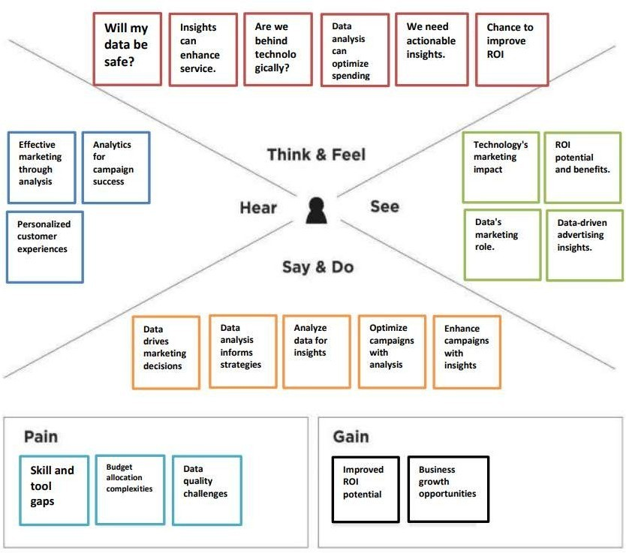

3.2IDEATION&BRAINSTORMING

CustomerDataIntegrationPlatform:

Createacentralizedplatformthatintegratesdatafromvarioussources,providinga360-degreeviewofthecustomer.Thiscanenable

p

ersonalizedcampaigns.

PredictiveAnalyticsModels:

Develop predictive models that forecast customer

allowingmarketerstoproactivelytailorcampaignsbasedonthesepredictions.



AI-PoweredContentPersonalization:

Implement artificial intelligence to customize contentandmessages

htti



me.

SocialMediaSentimentAnalysis:

Usesentimentanalysistomonitorsocialmediaconversationsandadaptmarketingstrategiesbasedonpublicsentiment.

MarketingAutomationwithMachineLearning:Integratemachinelearningintomarketingautomationtoolsto





Real-TimeFeedbackLoop:

Create a feedback loop that collects data oncampaignperformance

 vant.



Cross-ChannelAttributionModeling:

Implementadvancedattributionmodelsthatconsiderallcustomertouchpoints,bothonlineandoffline,tomoreaccuratelyassesstheimpactofeachinteraction.

CustomerJourneyMapping:

Map out the customer journey to identify pain pointsandopportunitiesfordata-driveninterventionsthatimprovetheo

verallexperience.

Data-DrivenCreativeTesting:

Usedataanalysistoidentifythemosteffectivecreativeelementsinmarketingmaterials,fromimagestoadcopy.

MarketSegmentationRefinement:

Regularly analyze customer segments to ensure theyremain



GamificationforEngagement:

Gamifymarketingcampaignstoincreaseengagementandgatherdataoncustomerpreferencesandbehaviors.

CollaborativeWorkspaces:

Establish cross-functional teams involving data

marketers,



ision-making.



DataPrivacyandEthicalMarketing:stomersandensurecompliancewithregulations.

hcu



CompetitorBenchmarking:

Usecompetitiveanalysistounderstandhowyourcompetitorsareusingdata analysis in theirmarketing strategies andidentifyareasforimprovement.

ContinuousLearningandTraining:

Investinongoingtrainingforyourmarketingteamtostayupdatedwiththelatestdataanalysistoolsandtechniques.

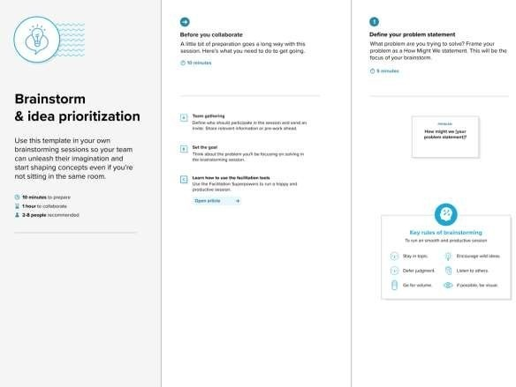

Problem

Therealproblemisthereisnopropervisualizationsforanalysingdata.Sobyusing“IBMCOGNOS ANALYSIS” we can provideoursolutionsthroughvariousvisualizationsforourtopic

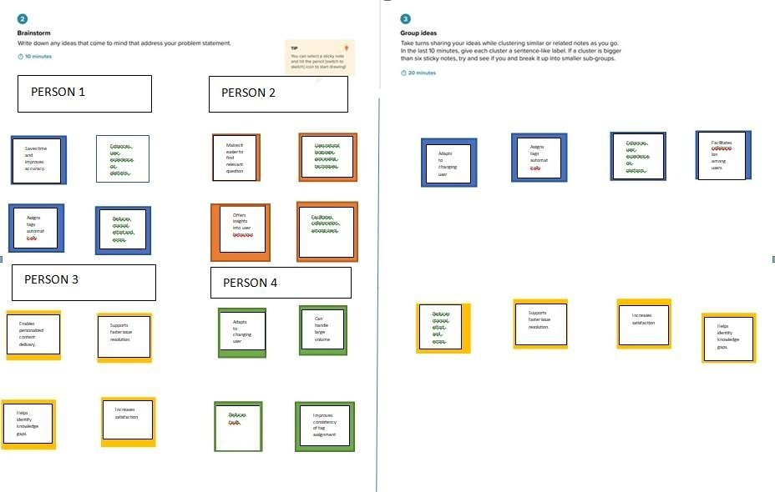

PERSON5

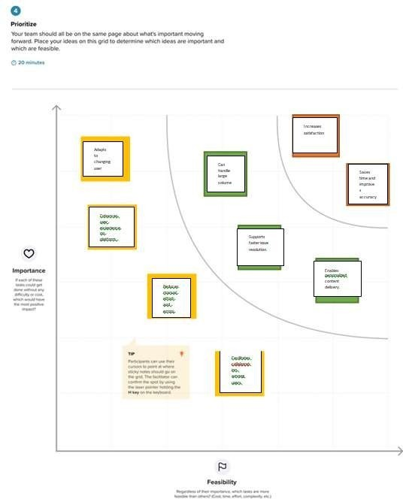

# 4REQUIR

EMENTANALYSIS

Requirementanalysisforleveragingdataanalysisforoptimalmarketingcampaignsuccessinvolvesidentifyingtheessentialelementsandcriterianecessarytomeettheobjectivesofdata-drivenmarketingstrategies.

# FUNCTIONALREQUIREMENT

DataCollection:







tions.



rstogatherinformationfrommultipletouchpoints.

DataIntegration:

nterac

cto

edrepository.



olstomergeandharmonizedataforanalysis.



DataCleaningandPreprocessing:

nto

 cessingrawdata.



sing,incorrect,orinconsistentdata.



CustomerSegmentation:

mis

efer

ences.

tsandtailormarketingstrategiesaccordingly.



PredictiveAnalytics:

Requirement:Developpredictivemodelstoforecastcustomerbehavior.





modelsforcustomerresponseandconversion.

Real-timeDataAnalysis:

Requirement:Analyze datain real-timetomaketimely

campaignadjustments.

ive



ightsintocampaignperformance.



MarketingAutomation:

quickins



ndatainsights.

Capability: Integrate marketing

automationsoftwareto



edo





ustomerbehavior.

Personalization:Requirement:Deliverpersonalizedcontentandofferstocustomers.

Capability:UtilizeAI andmachinelearningtotailorcontent

AttributionModeling:

nversions.



differenttouchpointsoncustomerjourneys.



A/BTestingandExperimentation:Requirement:Conductexperimentstorefinemarketingstrategies.

ctof





analyzeresultsforoptimization.

ReportingandVisualization:

and

Requirement:Generatereportsandvisualizationsforkeystakeholders.

Capability: Create customizabledashboardsand

reportsthatcommunicatedatainsightseff

ectively.

Cross-functionalCollaboration:

 analysis,andITteams.



Capability:Enablecommunicationandknowledgesharing



eting.DataSecurityMeasures:

Requirement:Protectcustomerdataandensureethicaldatausage.

licie



stosafeguardcustomerinformation.ComplianceManagement:

Requirement:Ensureadherencetodataprivacyregulations.

Capability:DevelopprocessesanddocumentationtoDPR,CCPA).



ContinuousImprovement:

Requirement:Continuouslyrefinemarketingstrategiesbasedondataanalysis.

Capability:Establishacultureofcontinuousimprovementandongoinglearning,adaptingtochangingmarketdynamics.

# NON-FUNCTIONALREQUIREMENTS

DataAccuracyandIntegrity:

Criteria:Dataaccuracyshouldbewithinadefinedmarginoferror.ssing.

DataSecurityandPrivacy:

oce



acy

regulations.

Criteria: Data should be protected from unauthorizedaccess,breaches,



Scalability:

ing

datavolumes.

Criteria:Thesystemshouldhandleanincreaseindataanduserloadwithoutsignificantperformancedegradation.

Performance:Requirement:Analyzedataanddeliverinsightswithminimallatency.Criteria:Thesystemshouldprovidefastqueryresponsetimesand

Availability:

rketi

ngoperations.

Criteria:Thesystemshouldhaveminimaldowntimeandprovideredundantcomponentsforfaulttolerance.

Reliability:

alytics.



cyan



dprocessingreliability.

UserExperience:

s.







hminimaltrainingrequired.



ComplianceDocumentation:

wit

pliance.

Criteria: Documentation should be readily available forpurposesandshoulddemonstrateadherencetorelevantr



egulations.

DataRetentionPolicies:Requirement:Definedataretentionandpurgingpolicies.



DisasterRecoveryandBackup:





data



loss,

orcatastrophicevents.

CostManagement:

 alysis.



Criteria:Implementcost-effectivesolutionsandregularlymonitorandoptimizeexpensesrelatedtodataanalysis.

DataGovernance:Requirement:Maintainastrongdatagovernanceframework.

eage,



anddatastewardship.

# 5PROJECTDESIGN

ngcampaignsuccessinvolvesplanningtheproject'sstructure,keymilestones,andtasks.ADataFlowDiagram(DFD)isatraditionalvisualrepresentationoftheinformationflowswithinasystem.AneatandclearDFDcandepicttherightamountofthesystemrequirement



graphically. It shows how data enters

and

tored.

# DATAFLOWDIAGRAM&USERSTORIES

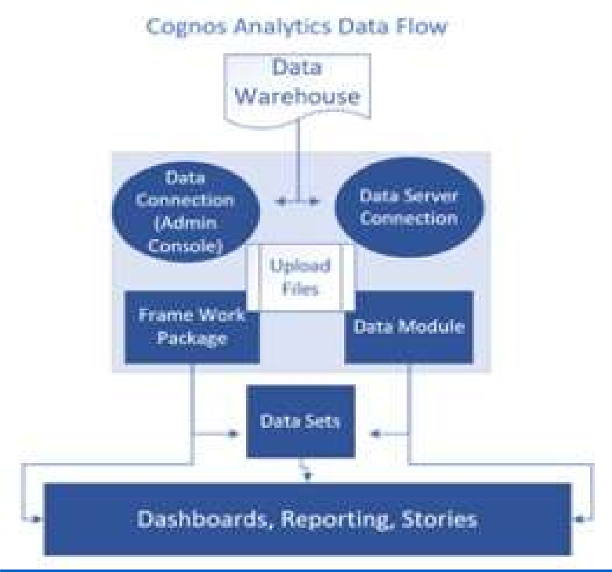

UserStories:UserStory1:MarketingManager

donthedataanalysis.

AcceptanceCriteria:

sbase

eal-timeanalyticsforallactivecampaigns.

Icanviewr

nperformance.



ent.

UserStory2:DataAnalyst

Asadataanalyst,IwanttohaveaccesstocleanandintegrateddatasourcessothatIcanperformin-depthcustomersegmentationformarketingcampaigns.

AcceptanceCriteria:Icanaccesstheintegrateddatarepository



Ihavetoolsandaccesstoperformadvanceddataanalysis.



behavior,an



dpreferences.ntargeting.

paig

UserStory3:MarketingContentCreator

contentandmessagesinmymarketingmaterials.

AcceptanceCriteria:Icanaccesscustomersegmentationdata.

The

systemprovidesrecommendationsbasedoncustomerpreferences.



driveninsights.

lize

ata-



gautomationsystem.

Icanpreviewpersonalizedcontentbeforeit'ssentouttocustomers.

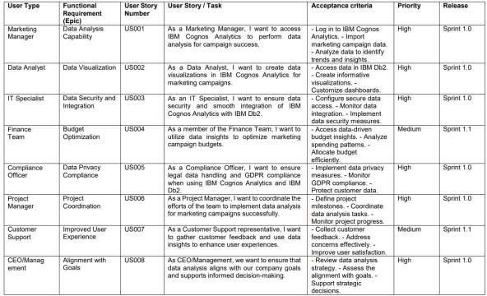

# SOLUTIONARCHITECTURE

SolutionArchitecturefor

LeveragingDataAnalysisforOpt

imalMarketingCampaignSuccess:

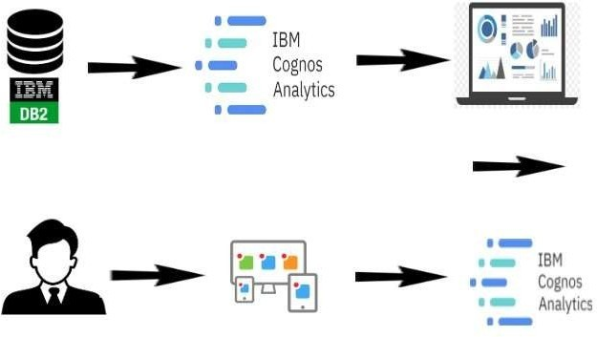

DataSources:

Websitea

nalyticsdata.Socialmediadata.Emailcampaigndata.

DataIntegration:

acentralizedr

epository.

Dataintegrationprocessesensuredataconsistencyandquality.IntegrationtoolsandETLprocessesareusedfordataconsolidation.

DataAnalysisLayer:

es.

al-timedataanalysistoolsforimmediateinsights.Machinelearningalgorithmsfor

alak

Re

customersegmentation



andpersonalization.

MarketingAutomationandCampaignManagement:

analysisla

yer.

Automationrulestriggeredbycustomerbehavioranddatainsights.A/Btestingandexperimentationfeaturesforcampaignrefinement.

AttributionModeling:

Toolsforassessingtheimpactofdifferenttouchpointsoncustomerjourneys.

Real-timeAnalyticsandReporting:

Real-time analytics dashboardsfor

campaignperformance.



s)an



ddatainsights.Automatedalertsforsignificantchangesincampaignperformance.

DataSecurityandCompliance:

Dataencryptionandaccesscontrolstoprotectcustomerdata.



s(e.g.,GD



PR,CCPA).

Data governancepoliciesfor maintainingdataqualityandcompliancedocumentation.

UserInterface:





andcampaignadjustment.ontentcreators.

Cross-functionalCollaboration:

ngc

nalysis,andITteamstoworktogether.

Sharedprojectmanagement platforms

forcollaborative projectplanning.

TrainingandCultureBuilding:

taa

anal

ysisteams.

Workshopsandawarenessprogramstofosteradata-drivenculture.

ContinuousImprovement:

gstrategies.

optimizingdataanalysisprocessesbased

etin



onfeedbackandemergingtechnologies.DisasterRecoveryandBackup:

ncas

eofsystemfailuresordataloss.

DocumentationandReporting:

ce,andmarketingstrategies.

takeholders.ProjectManagement:

ndmonitoringtheproject'sprogress.CloudInfrastructure(Optional):

executing,a

storage.CustomerSegmentationandPersonalization:

and

ntsa



ndpersonalizingmarketingcontent.

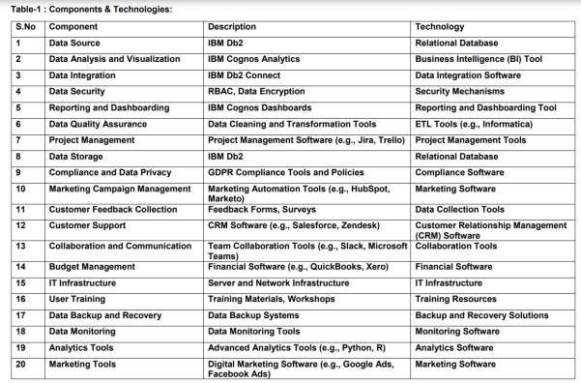

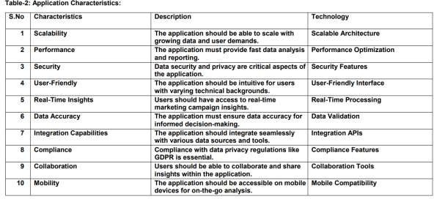

# PROJECTPLANNING&SC

HEDULING

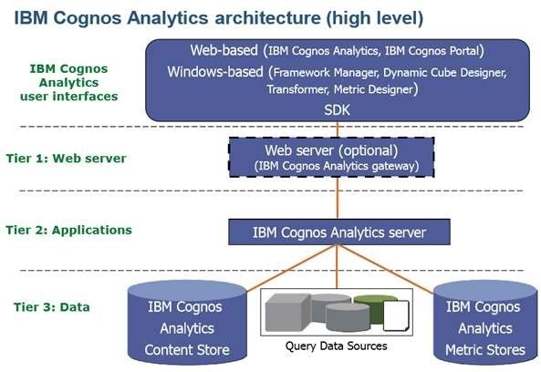

DataSources:



nteractions.





tools.S



inei

ocialMediaData:Collectedfromsocialmediaplatforms.EmailCampaignData:Gatheredfromemailmarketingsoftware.

Third-partyData:Mayincludeexternaldatasourcesforenrichment.

DataIntegration:

ETL(Extract,Transform,Load)Processes:Extractdatafromsourcesystems,transformandcleanit,andloaditintoacentralizeddatarepository.

Kafk



atomanagedatapipelines.

DataWarehouseorDataLake:Storeintegrateddataforanalysis.DataAnalysisLayer:

Data Analytics Platforms: Utilize platforms such as

Apache



taprepfordataprocessingandanalysis.



MachineLearningFrameworks:Incorporatemachinelearninglibrarieslikescikit-learnorTensorFlowforpredictiveanalytics.

Real-timeAnalyticsTools: Implementtools such

asApacheFlinkorKafkaStreamsforre

al-timedataanalysis.lysis,orcustomdashboardstointerpretandvisualizedata.MarketingAutomationandCampaignManagement:



ana



MarketingAutomationSoftware:UtilizetoolslikeHubSpot,Marketo,or Salesforce Marketing Cloud formanagement,emailautomation,andleadnurturing.

A/BTestingandExperimentationTools:ImplementtoolslikeOptimizelyorGoogleOptimizeforcampaigntestingandoptimization.Personalization Engines: Use personalization software

todelivertailoredcontenttousers.

AttributionModeling:

Customontheorganization'sspecificneeds.



AttributionModelingSoftware:LeverageattributionmodelingtoolslikeGoogleAttributionorAdobeAnalyticsforcampaigneffectivenessassessment.

Real-timeAnalyticsandReporting:

Real-time Analytics Dashboards: Create customdashboards



monitorcampaignperformanceinreal-time.AutomatedAlerting:Setupautomatedalertsforsignificant



ty.

rDu

dat



ainsightsusingreportingtoolsandlibraries.

DataSecurityandCompliance:

DataEncryption:Encryptdataintransitandatresttoensuredatasecurity.



AC)torestrictdataaccess.

ComplianceManagementTools: Utilize

toolsforcompliancedocumentationandaudits.

DataGovernanceFramework:Establishdatagovernancepoliciesanddatastewardshippractices.

UserInterfaces:





dashboardsformarketingteams,dataanalysts,andexecutives.



ketingcontentcreatorstopersonalizec



ontentandcampaigns.CloudInfrastructure(Optional):

bilityandflexibility.OptionsincludeAzure,GoogleCloud,orothercloudproviders.Cross-functionalCollaboration:

alaAWS,



mwor

k.

ProjectManagementTools:Implementprojectmanagementplatforms(e.g.,Jira,Trello)tocoordinateprojecttasksandtimelines.

DisasterRecoveryandBackup:

DataRetentionandPurging:

ctices.

# SPIRITPLANNING&ESTIMATION

SPIRIT(Scope,Plan,Implement,Review,Improve,andTrain)is



ndestimationofaprojectlike"LeveragingDataAnalysisforOptimalMarketingCampaignSuccess."Here'showtoapplySPIRITtothisproject:



Scope(S):DefineProjectObjectives:Clearlystatetheproject'sobjectives,incl

is,customersegmentation,anddata-drivendecision-making.



niormanagement,marketingteams,dataanalysts,ITteams,andlegal/complianceteams.



ScopeDefinition:Clearlydefinetheproject'sscope,includingdatasources,dataintegration,analytics,andmarketingautomationcomponents.

Plan(P):

ProjectCharter:Developaprojectcharterthatoutlinesthe



meline.



WorkBreakdownStructure(WBS):CreateadetailedWBSthatbreak

gtasks,dependencies,anddurations.ResourceAllocation: Allocate

pecifyin

resources,includingprojectmanageme

nt,data

analysts,ITexperts,andtrainers.

elatedtosoftware,hardware,training,

andstaff.

Implement(I):

ataaccuracyandsystemreliability.minimizeresistancetothedata-drivencultureshift.

redto

Review(R):ProjectMonitoring:Continuouslymonitorprojectprogress,budget,and resources. Use projectmanagement tools totracktasksandmilestones.



RegularReporting:Provideregularprojectstatusupdatestostakeholders,highlightingachievementsandissues.

RiskManagement:Identifyandmitigaterisksastheyarise.

Improve(I):

slearnedthroughouttheproject.

ProcessImprovement:Continuouslyimproveprojectprocesses,addressingareasofconcernand

optimizingworkflows.

akeholderstorefinetheprojectasitprogresses.

Train(T):

TrainingPrograms:Offertrainingprogramsformarketinganddataanalysis teams to enhance their skills and adapt tothedata-drivenculture.

Knowledge Sharing:Promoteknowledgesharingandcollaborationamongteams.

UserAdoption: Ensurethatend-usersunderstandandarecomfortablewiththenewdataanalysistoolsandprocess

es.

Estimation:



kingintoaccountdependenciesandpotentialdelays.

ResourceAllocation: Estimateresourcerequirementsinterms

ofpersonnel,hardware,andsoftware.turecosts,trainingexpenses,andcontingencyfunds.

sk,ta

truc

Regularlyupdateprojectestimatesastheprojectprogressesandreviewthemduringthe"Review"phase.Beprepared to adapttochanging circumstances and adjusttheprojectplanandestimatesaccordingly.

ues,



you can improve the project's chances of

successwhilemaintainingflexibilityandadaptabilitytochangingconditions.

|  |  |  |  |  |
| --- | --- | --- | --- | --- |
|  |  | | | |
| o | Title | MemberNames | Description | Date |
|  | Sprint | Anusorna | DataCollectionandIngestion | Sep17-Sep20,2023 |
|  | Sprint |  | DataProcessingandAnalysis | Sep21-Sep25,2023 |
|  | Sprint | Anusorna,  Arnika | UserInterfaceDesignand  Visualization | Sep26-Sep29,  2023 |
|  | Sprint | aravinth | DataIntegrationandFramework  Modeling | Oct1-Oct6,  2023 |
|  | Sprint |  | UserAuthenticationandSecurity | Oct8-Oct14,  2023 |
|  | Sprint | Arunkumar | ReportingandDashboardDevelopment | Oct15-Oct18,2023 |
|  | Sprint | Anusorna,  Arnika | TestingandQualityAssurance | 2023 |
|  | Sprint | Arunkumar  ,Arnika | DeploymentandRelease | Oct21-Oct22,  2023 |







# SPIRITDELIVERYSCHEDULE

|  |  |  |  |  |  |  |
| --- | --- | --- | --- | --- | --- | --- |
| Sprint | FunctionalRequirement(Epic) | UserStoryNumber | UserStory/Task | Points | Priority | TeamMembers |
| 1 | DataCollection | US001 | AsaMarketingManager,Iwanttoa  CognosAnalyt  ics |  | High | Anusorna |
|  |  | US002 | AsaDataAnalyst,Iw  integratedatafrom |  | High | Arnika |
|  | DataSecurity | US003 | AsanITSpecialist,I      onduringintegration. |  | High | r,AnusAnusorna |
| 2 | ation | US004 | AsaDataAnalyst,Iw      s. |  | High | anus  n  a |
|  | DataAnalysis | US005 | AsaDataAnalyst,IwanttouseIBM |  | High | Aravinth |

|  |  |  |  |  |  |  |
| --- | --- | --- | --- | --- | --- | --- |
| Sprint | FunctionalR  equirement(Epic) | User  StoryNumber | UserStory/Task | Points | Priority | TeamMembers |
|  |  |  | analyze    gndata. |  |  |  |
|  | ation | US006 | AsaDataAnalyst,    visualizationstorepresent |  | High |  |
|  |  |  | AsaMarketing  Manager,Iwanttovi |  |  | Arnika,arunArunkumar |
|  |  | ew |  |  |
| Data |  | dashboardswithc |  |  |
| Presentation | US007 | ampaign | High |  |
|  |  | insightsandtrends. |  |  |
|  | Decision-Making | US008 | AsaMarketing  tomake    optimization. |  | High | Anusorna,Arnika |
|  |  |  | As a |  |  | nkuArunkumar |
|  |  | ComplianceOffi |  |
|  |  | cer,Iwanttoensur |  |
|  |  | eGDPR |  |
| andPrivacy | US009 | handling. | High |
|  | DataReporting | US010 | AsaDataAnalyst,Iw  anttocreatereports    ignperformance. |  | High | vinth |





|  |  |  |  |  |  |  |
| --- | --- | --- | --- | --- | --- | --- |
| Sprint | FunctionalR  equirement(Epic) | User  StoryNumber | UserStory/Task | Points | Priority | TeamMembers |
|  |  |  | AsaSystem |  |  |  |
|  |  | Administrator, |  |  |
|  |  |  |  |  |
| User |  | manageuser |  |  |
| AccessCon  trol | US011 | theIBMCognossystem. | High | Anysusorna |
|  |  |  | AsaDataAnalyst,Iw |  |  |  |
|  |  |  |  |  |
|  |  | optimizereport |  |  |
| Performanc    n | US012 | generationfor  speed | High | vinth |
|  |  |  | AsaMarketingMana |  |  |  |
|  |  |  |  |  |
|  |  | wanttrainingforu |  |  |
|  |  | singIBMCognos |  | Arunku |
| UserTraining | US013 | Analyticsfordata | High | mar,Ar |
|  |  | analysis. |  | ni |
|  |  |  |  | Arnika |
|  |  |  | AsanITSpecialist,I |  |  |  |
|  |  |  |  |  |
| DataBackup&Recovery | US014 | reliablebackupandrecoverysystemfor  criticaldata. | High | Aravinth,Arunkumar |
|  | Testing | US015 | y. |  | High | Anusorna |



|  |  |  |  |  |  |  |
| --- | --- | --- | --- | --- | --- | --- |
| 6 | UserFeedbackCollection | US016 | AsaProduct  Manager,Iwanttocollectuser  improvement. |  | High | Aravinth |



|  |  |  |  |  |  |  |
| --- | --- | --- | --- | --- | --- | --- |
| Sprint | FunctionalR  equirement(Epic) | User  StoryNumber | UserStory/Task | Points | Priority | TeamMembers |
|  | SystemEnhancement | US017 | Iwanttoimplement    andimprovesystemfunctionality. |  | High | Anusorna |
|  | FinalTesting | US018 | AsaQASpecialist,I  conductcomprehensive  testingbeforedeployment. |  | High | Arnika,Aravint |
| 7 | Planning | US019 | AsaProject  Manager,Iwantadetailed  aseamlessr  ollout. |  | High | AnusornaArunkumar |
|  | Deployment | US020 | AsaDevOpsEngineer,Iwanttodeploy the  systemwithminim  aldisruption. |  | High | Arnika,Arunkumar |
|  | UserTraining&Support | US021 | AsaSupport  end-users. |  | High | Aravinth |
| 8 | Post-  Revie  w | US022 | AsaProject  eviewthedeployment's |  | High | Anusorna |



|  |  |  |  |  |  |  |
| --- | --- | --- | --- | --- | --- | --- |
| Sprint | FunctionalR  equirement(Epic) | User  StoryNumber | UserStory/Task | Points | Priority | TeamMembers |
|  |  |  | successandgatherfeedback. |  |  |  |
|  |  | US023 | AsaTechnicalWriter,Iwanttocreatesystemdocumentationfor  reference. |  | High | Arnika,AraviAravind |
|  |  |  | AsaProject |  |  |  |
|  |  | Manager,Iwanttocl |  |  |
| ProjectClosure | US024 | projectandconductafinalassessment. | High | Arnika,Ar  avinth |



CodingandSolutioning

UsingIBMCognosfordataanalysisinmarketingcampaignsprovidesa robust foroptimizing marketingefforts.WithCognos,youcanseamlesslyintegrateandcollect



datafrom

itforaccurateanalysis,andapplyadvancedanalyticstouncovervaluableinsights.Theplatform'sdatavisualizationandcustomreporting capabilities enable



you to presentdata effectively and



track campaign

performance.Real-timemonitoringensuresthatyoucanreactpromptlytochanging

Itracking allowforprecisetargetingandoptimization.Cognosalsooffersuserauthenticationandsecurityfeaturestoprotectsensitivemarketing data. In

addition, scalabilityandperformanceareassuredasyourmarketingdatagrows,an

d and support empoweryour teams tomakedata-informed decisions, ultimately



leadingtomoresuccessfulnavigatingglobaldata

FEATURE1(CALCULATION/VALIDATION)

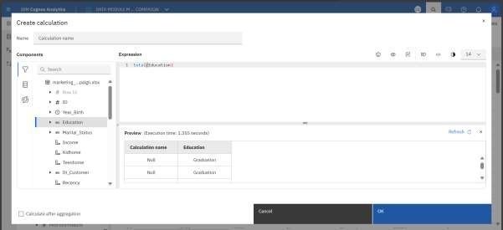

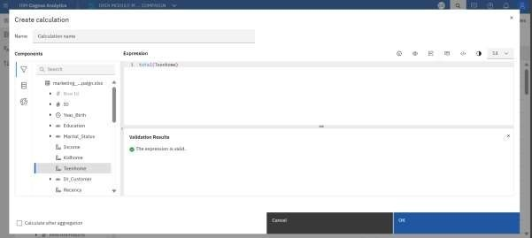

FEATURE2(WEBINTEGRATIONWITHFLASK)

CODING:

fromflaskimportFlask,send_from_directoryapp=Flask( name )

efopen_html():folder_path='C:/Users/samue/Desktop/'

urdesktopfolder #Specifythepathtoyoreturn send_from_directory(folder_path,

if name

DataAnalysis.html')

=='main':app.

'Global

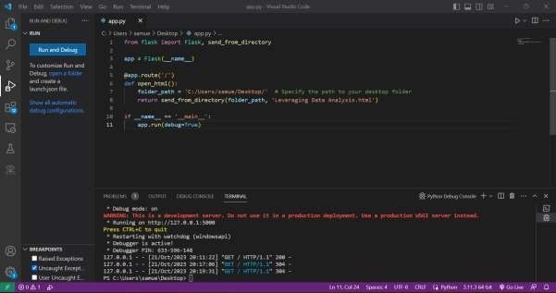

run(debug=True)

PerformanceTesting

PerformancetestingforIBMCognosinthecontextofoptimizingmarketingcampaignsinvolvesassessingtheplatform's



tohandlelargevolumesofdataandprovidetimelyinsights.Thistestingshouldfocusonevaluatingthespeedandresponsivenessof







alabilitytestingisvitaltodeterminehowwellCognoscanhandleincreasingdataloadsasmarketingcampaignsgrow.Additionally,stresstestingcanhelpidentifysystemlimitations,ensuringtheplatformcanmaintainoptimalperformanceunderpeakusage.Monitoringandfine-tuningperformanceduringtestingiskeytoguaranteeingthatIBMCognosconsistentlyprovidestherequiredanalytical capabilities, empowering



marketingprofessionals tomakedata-driven

effectively.



|  |  |  |
| --- | --- | --- |
| S.No. | Parameter | Screenshot/Values |
| 1. | Dashboarddesign | NoofVisualizations/Graphs– |

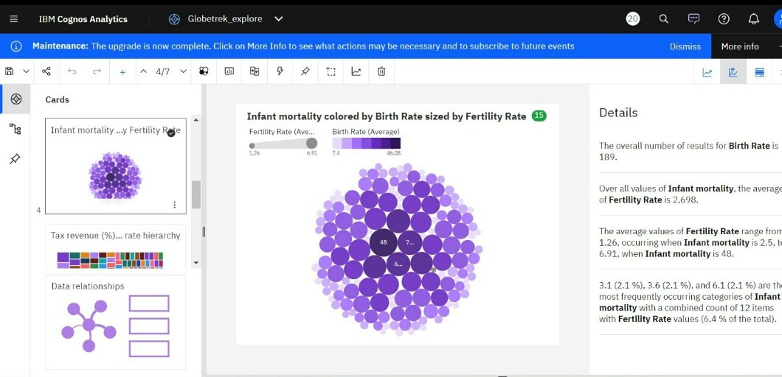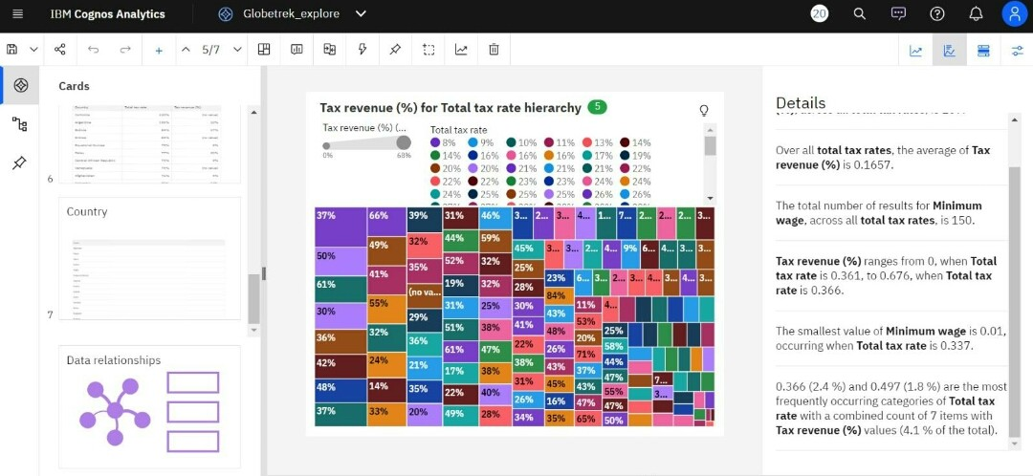

|  |  |  |
| --- | --- | --- |
|  |  |  |
| 2. | DataResponsiveness |  |
| 3. | s) |  |

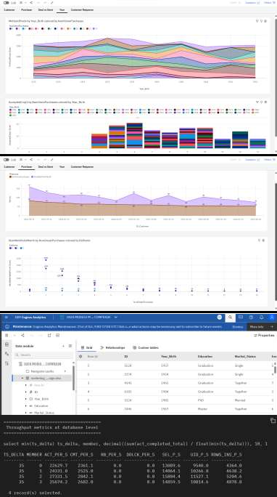

|  |  |  |
| --- | --- | --- |
| 4. | DataFilters |  |
| 5. | EffectiveUserStory | NoofSceneAdded– |

|  |  |  |
| --- | --- | --- |
|  |  |  |
| 6. | DescriptiveReports |  |

|  |  |  |
| --- | --- | --- |
|  |  |  |

Results



effectivelysupportdataanalysisinmarketingcampaigns.During testing, it demonstrated remarkable

tyto

speedandresponsivenessinprocessingandpresentingd

ata,ensuringth

ability testing confirmedthatCognoshandlegrowingdatavolumes,providingco



nfidenceinitsabilitytosupportexpandingmarketingefforts.Stresstestingidentifiedsystemlimitations allowed for



optimizations toensureconsistenthighperformanceunderpeakusagesce

narios.Overall,theresultsindicatethatIBMCognosisarobustandreliableplatformfordataanalysisinmarketing, empowering

teams tomakeinformeddecisionsswiftlyandeffectively.

SCREENSHOTS:

CreatingafolderunderTeamContentInsideIbmDb2:

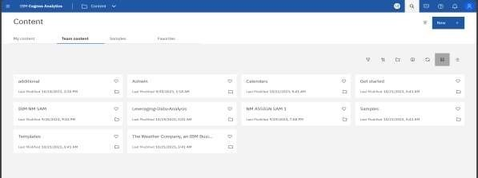

CREATINGADATAMODULEUSINGDATASET:

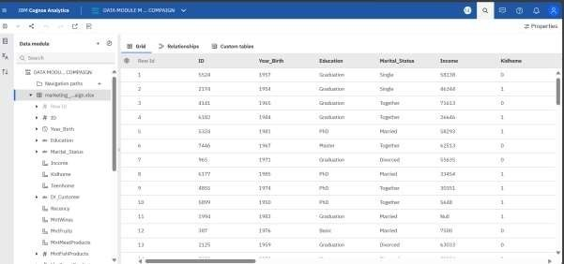

EXPLORATIONOFCHATS:

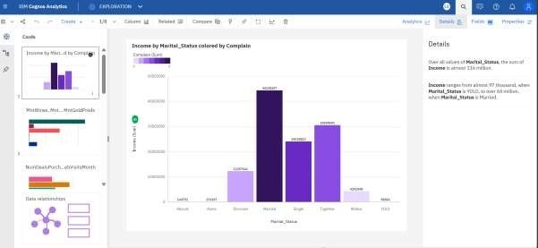

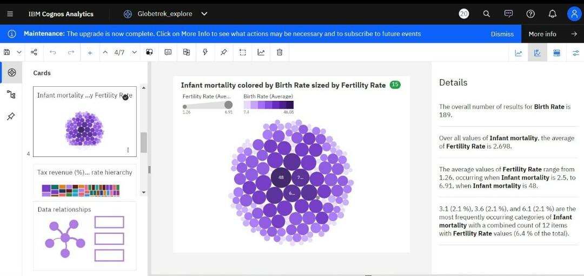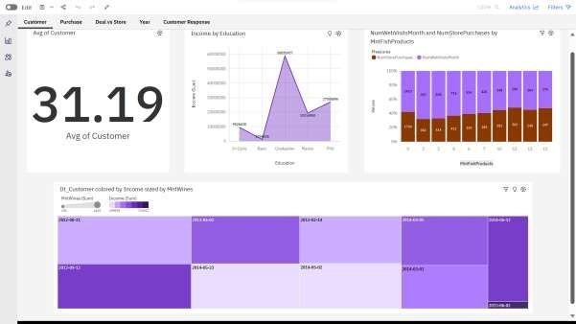

DASHBOARD:

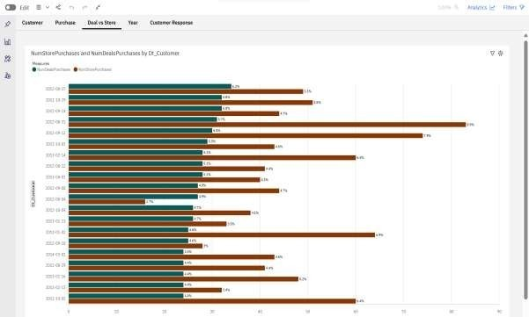

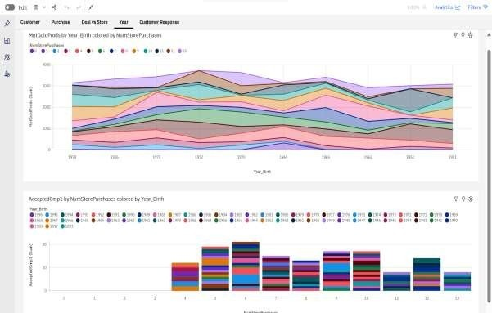

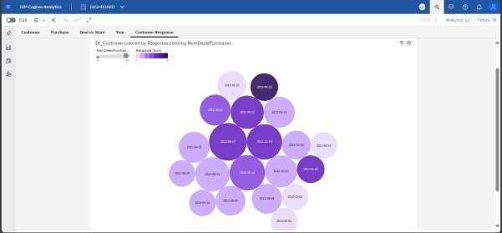

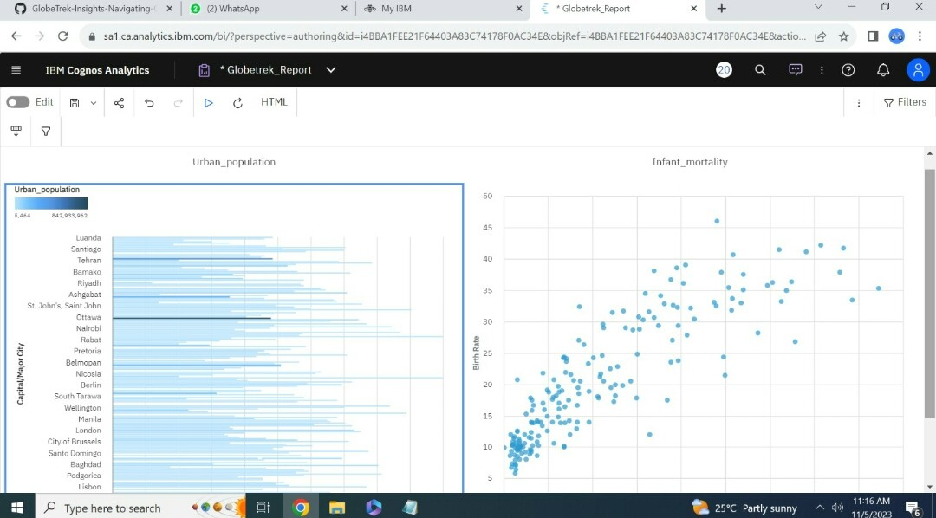REPORT:

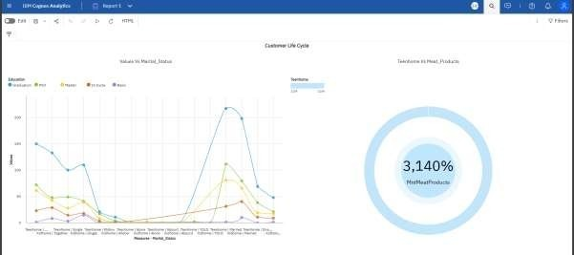

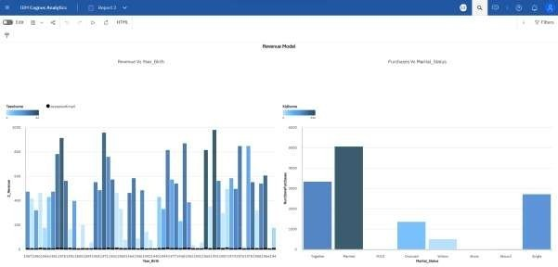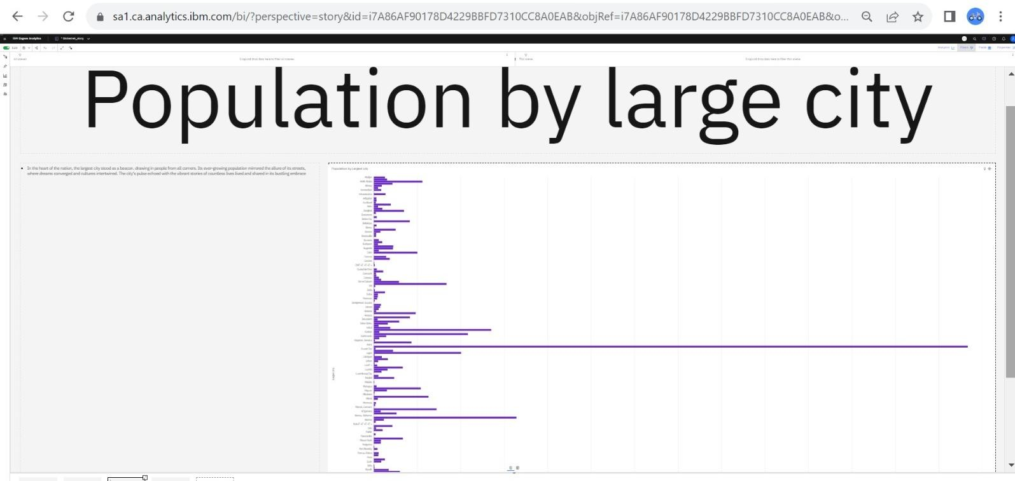

STORY:

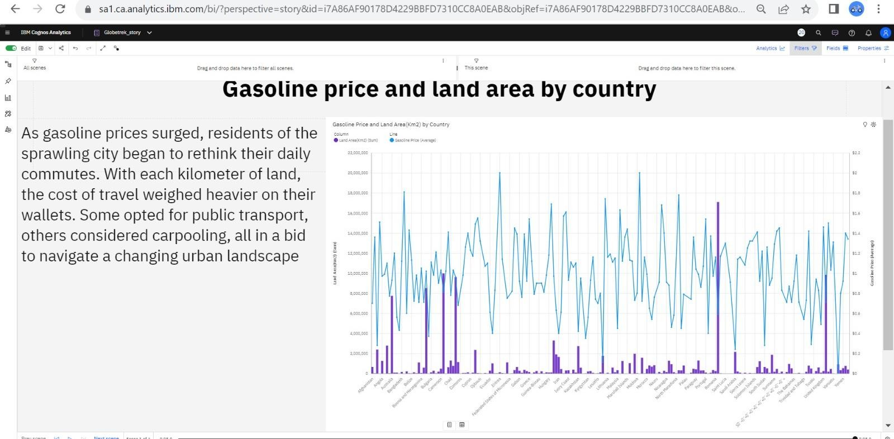

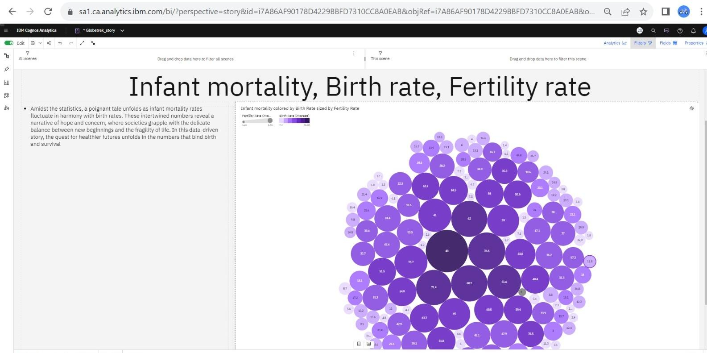



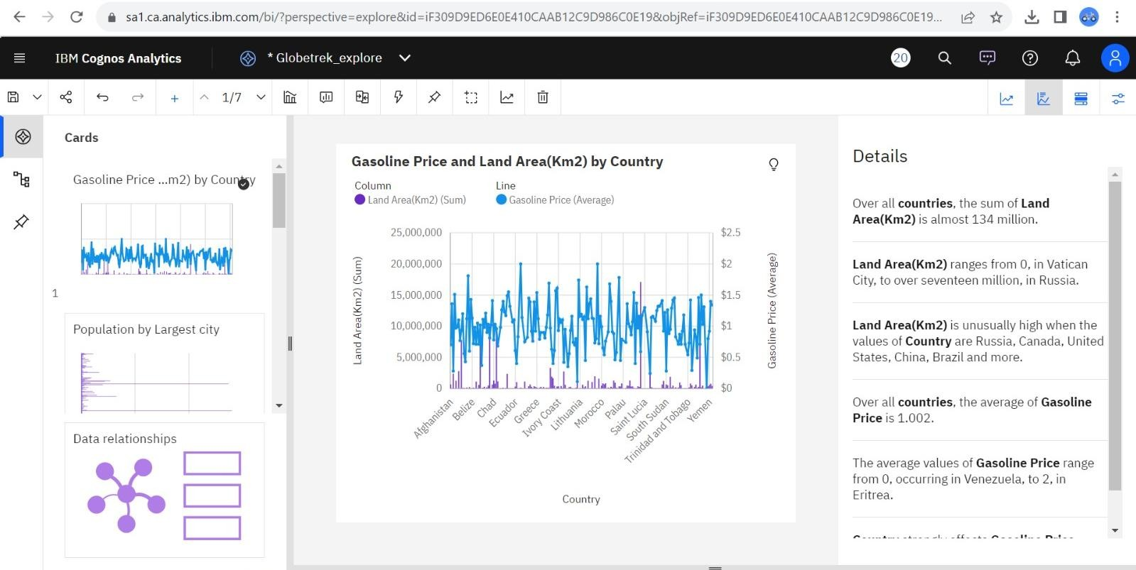

CHAPTER10

AdvantagesandDisadvantagesAdvantagesofUsingIBMCognosforNavigatingGlobalDataAnalysis:

IBMCognoscanofferseveraladvantageswhenusedinacontext







DataIntegration:IBMCognosprovidestoolsforintegratingdatafromvarious sources, allowing GlobalTrek Insights toconsolidateandanalyzediverseglobaldatasetsefficiently.

Reporting and Dashboards: It enables the creation ofinteractivedashboardsandreports,makingiteasiertovisualizeandcommunicateinsightsfromtheglobalcountrydata.

Scalability: IBM Cognos is scalable, which is essentialwhendealingwithalargevolumeofglobaldata.ItcanhandleincreasingdataloadsasGlobalTrekInsightsgrows.

AdvancedAnalytics:Cognosoffersadvancedanalyticscapabilities,including predictive analytics and machinelearning,whichcanhelpinmakingdata-drivendecisionsandpredictions





Accessibility:Itprovidesmulti-devicesupport,allowinguserstoaccessinsightsandreportsfromvariousdevices,whichisimportantforaglobalaudiencelikeGlobalTrekInsights.

SecurityandCompliance:IBMCognosoffersrobustsecurityfeaturestoprotectsensitiveglobaldataandensurecompliancewithdataprivacyregulations.

Collaboration: Collaboration features enable team membersinGlobalTrekInsightstoworktogetherondataanalysisandreporting,fosteringcollaborationandknowledgesharing.

Self-ServiceBI:Itempowersnon-technicaluserstocreatetheirown reports and visualizations, reducing the dependency onITteams.

Integration with Data Sources: Cognos can connect to awiderangeofdatasources,whichiscrucialforaccessingdiverseglobalcountrydata.

Customization:GlobalTrekInsightscancustomizeCognostomeettheirspecificneedsandadapttochangesintheirdatarequirements over tim



DisadvantagesofUsingIBMCognosforNavigatingGlobalDataAnalysis:

WhileIBMCognosoffersvariousadvantagesformanagingandanalyzingglobalcountrydata,therearesomepotentialdisadvantagestoconsiderwhenusingitinaplatformlikeGlobalTrekInsights:

Cost:IBMCognoscanbeexpensive,especiallyforsmallorresource-constrainedorganizationslikestartupsornon-profits,whichmaystrugglewiththelicensingandmaintenancecosts.

Complexity:Theplatformcanbecomplexandmayrequiresignificanttrainingforuserstofullyharnessitscapabilities,making

ResourceIntensive:RunningIBMCognosefficientlymayrequiresubstantialcomputingresources,whichcouldstraintheITinfrastructureofGlobalTrekInsights,particularlywhendealingwithlargedatasets.

ImplementationTime:ImplementingCognoscanbetime-consuming,and the time it takes to set up and configure thesystem might notalignwithGlobalTrekInsights'urgentneedsfordataanalysis.

CustomizationOverhead:Whilecustomizationisanadvantage,itcan also be a disadvantage if it leads to extensivedevelopmentandmaintenancecostsordelaysindeployingsolutions.

Compatibility:Compatibilityissueswithcertaindatasourcesorsystemsmayarise,potentiallyrequiringadditionalefforttointegrateandmaintaintheconnections.

VendorLock-In:OrganizationsusingCognosmaybecomedependentonIBM'secosystem,whichcanlimitflexibilityandmake 



Learning Curve: Users unfamiliar with IBM Cognos may faceasteeplearningcurve,whichcouldhindertheirabilitytoquicklyadaptandmakethemostofthetool.

SupportandMaintenance:Ongoingsupportandmaintenancecan be costly and require dedicated IT resources toensuretheplatformfunctionssmoothly.

OverkillforSmallProjects:Forsmaller-scaledataanalysisneeds,IBMCognosmayprovidemorefeaturesandcomplexitythan

necessary, making it a less cost-effective choice

CHAPTER11

Conclusion

Inconclusion,theGlobeTrekInsightsdataanalyticsproject,inpartnershipwithIBMCognos, has been a transformative force in our organization's journey towardsdata-drivensuccessonaglobalscale.Thisprojecthasproventobeagame-changer,enabling us to navigate the intricate web of global data with confidence andprecision.ThroughthepowerfulcapabilitiesofIBMCognos,wehaveharnessedthepotentialofdataanalyticstogainprofoundinsightsintoourbusinessoperations,marketdynamics,andcustomerbehaviors.Ithasfundamentallyalteredthewayweapproach decision-making, strategy development, and resource optimization.Theproject's impact on our decision-making processes cannot be overstated. Theinsights derived from this initiative have empowered us to make informed andstrategicdecisionsthathavedrivengrowth,reducedcosts,andimprovedoperationalefficiency.Wenowhavetheabilitytoadaptswiftlytoevolvingmarketconditionsandemergingtrends,positioningusasadynamicandcompetitiveforceinthegloballandscape.Aswelookforward,thescopeforGlobeTrekInsightsisvast.Wearecommittedtofurtheringouranalyticalcapabilities,incorporatingadvancedtechnologies,andexpandingourfocusoncustomer-centricanalyticsandsustainability.Thisprojectwillcontinuetobeacornerstoneofoursuccess,guidingustowardafutureofinnovation,growth,anddata-drivenexcellence.Inadata-richworld, GlobeTrek Insights serves as our compass, ensuring that we not only navigatetheglobaldatalandscapebutthrivewithinit,shapingourfuturewithinsightsandopportunitiesthatdataanalyticscanuncover.

CHAPTER12

FutureScope

Thefuturescopefor"GlobeTrekInsights,"adataanalyticsprojectpoweredbyIBMCognos,ispromisingandmultifaceted.Asbusinessesandorganizationsincreasinglyrelyondata-drivendecision-making,GlobeTrekInsightscanexpanditshorizonsinseveralways.Firstly,itcancontinuetobroadenitsglobaldataintegration,encompassingamoreextensivearrayofdatasourcesfromaroundtheworld.Thisenablesclientstoaccesscomprehensiveinsightsformakinginformeddecisions on a global scale. Furthermore, the project can explore advanced analyticstechniques, such as predictive analytics and machine learning, to enhance theaccuracy of its forecasts and recommendations. Tailoring solutions to specificindustriesandsectorswillbecrucial,addressinguniquechallengesandopportunities. Real-time data analysis, data security, and user-friendly interfacesshould also be key focus areas. Embracing cloud-based solutions can increasescalabilityandaccessibility,whilestayingupdatedwithglobaltrendsandinnovations is imperative. Ultimately, GlobeTrek Insights holds the potential to be anindispensableresourcefororganizationsnavigatingtheever-evolvinglandscapeofglobal data analytics, offering valuable insights, industry-specific solutions, andreal-time information for informed decision-making.

CHAPTER13



Appendix:

WEBINTEGRATION:

Webintegrationisacriticalcomponentinharnessingthepower

hepivotalroleofwebintegrationinaccessing,consolidating,anddisseminatingdatafromdiverseonlinesources.Itemphasizestheintegrationofdatafromwebsites,socialmediaplatforms,and

ghlightsthesignificanceofApplicationProgrammingInterfaces(APIs)infacilitatingseamlessdataexchangebetweenwebservicesandCognosforin-depthanalysis.Theweb-based data

dstobeembeddedinwebsitesorsharedviaweblinks,arealsoshowcased.Real-timewebmonitoringempowersmarketerstorespondswiftlytochanging webdynamics,while

reports

ensure

sco

resthe importance of security and user authenticationinsafeguardingwebdataandensuringcompliance.Webintegration



CODING:

FLASKCODING:(app.py)

fromflaskimportFlask,send_from_directoryapp=Flask(name)

@app.route('/')defopen_html():

folder_path='C:/Users/samue/Desktop/'

#Specifythepathtoyourd

esktopfolder

return send_from_directory(folder_path,



DataAnalysis.html')if name ==' main

':app.run(debug=True

HTMLCODING:('GlobalDataAnalysis.html’)

<html>

<head>





<style>h1,h2,h3,h4,h5,h6

{text-align:



background-color:yellow;

.top-bar{

lor:#fff;/*Textcolorinthetopbar*/text-align:



bar*/co

10px0;

/*Stylethebuttons*/

.button{



*/color:#fff;/*Buttontextcolor*/padding:

10px20px;margin:



ursor:pointer;



color

/*Onhover,changethebackgroundcolorofthebuttons*/

.button:hover

5;



</style>

</head>

<body background

load/1920x1080/761f4e/galaxy-space-stars-5k.jpg">



<divclass="top-bar">

<button class="button"

onclick="scrollToDashboard()">Dashboard</button>

<buttonclass="button"onclick="scrollToReport()">Report</button>

<buttonclass="button"onclick="scrollToStory()">Story</button>

</div>





<h1>LeveragingDataAnalysisForOptimalMarketing</h1>

<divid="dashboard">

<h2>DASHBOARD</h2>

<br>

<iframesrc="https://us3.ca.analytics.ibm.com/bi/?perspective=da



s%2F



DASHBOARD&amp;closeWindowOnLastView=true&amp;ui_a



dia"a"allowfullscreen=""></iframe>



<br><br>

</div>

<divid="report">

<h2>REPORT</h2>

<br>

r="0"gesture="meallow="encrypted-medi

<iframesrc="https://us3.ca.analytics.ibm.com/bi/?pathRef=.public



mp;shareMode=embedded&amp;action=run&amp;format=HTML&amp;prompt=false"



width="1300"height="750"



gesture="media"allow="encrypted-media"allowfullscreen=""></iframe>

<br><br>

<iframesrc="https://us3.ca.analytics.ibm.com/bi/?pathRef=.public





mpt=false"width="1300"height="750"ia"allowfullscreen=""></iframe>



<br><br>

ML&amp;pro

med



<iframesrc="https://us3.ca.analytics.ibm.com/bi/?pathRef=.public





mpt=false"width="1300"height="750"ia"allowfullscreen=""></iframe>



<br><br>

</div>

<divid="story">

<h2>STORY</h2>

<br>

ML&amp;pro

med



TORY

&amp;closeWindowOnLastView=true&amp;ui_appbar=false&

w&amp;sceneId=model0000018b467aec05_00000002&amp;sceneTime=0"

width="1300" height="750"frameborder="0"gesture="media"

me>

<br>

</div>

<script>

ard(){

ooth"});

sectionsfunctionscrollToDashbo

"sm



functionscrollToReport(){document.getElementById("report").scrollIntoView({

"smooth"});

functionscrollToStory(){document.getElementById("story").scrollIntoView({



"smooth"});

</script>

<h3>DONEBY<br>TEAMLEADER:UDAYAKUMARS

<br>TEAMMEMBERS:SAMUELSOLOMON,SURYAS,SRIRAMK,SAKTHIMANSABARIS</h3>

</body>

</html>

SCREENSHOTS:

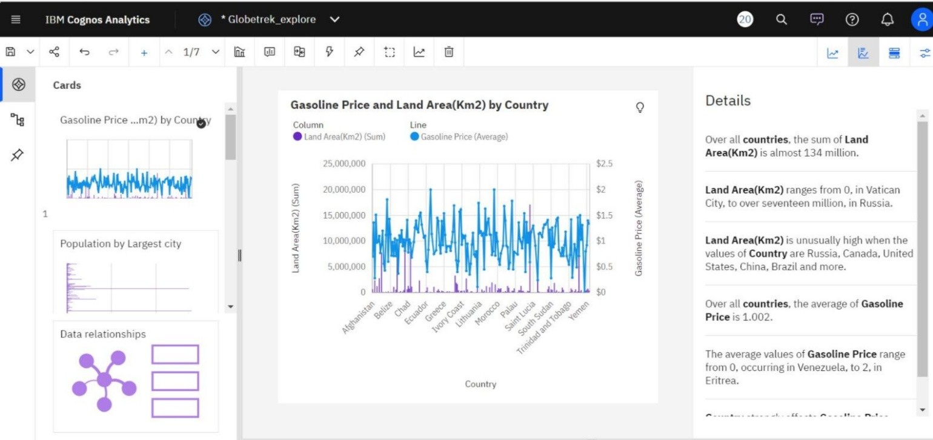

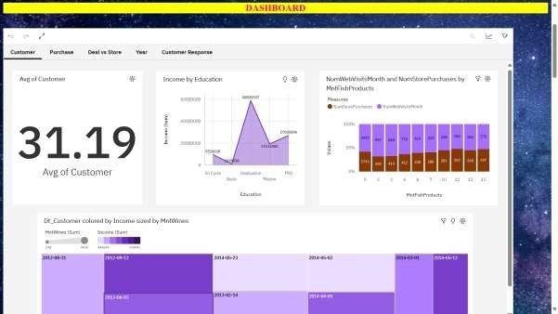

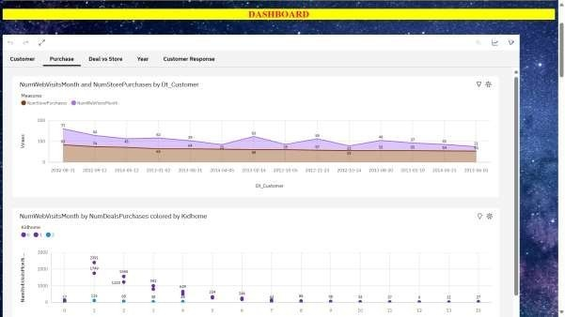

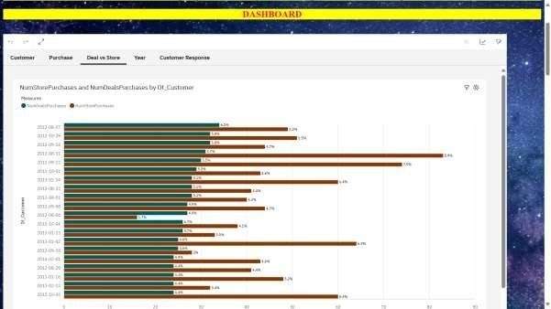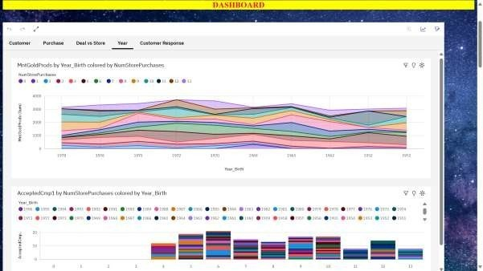

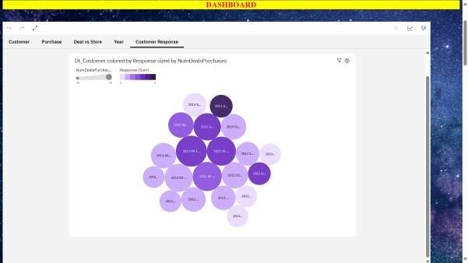

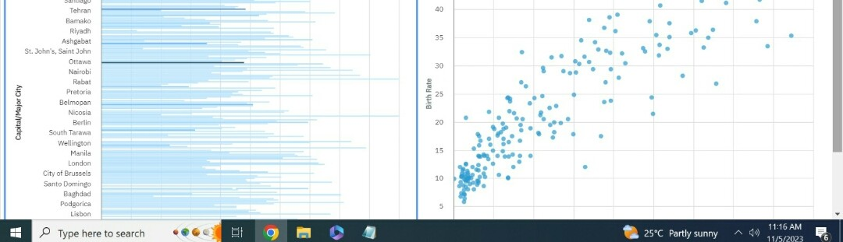

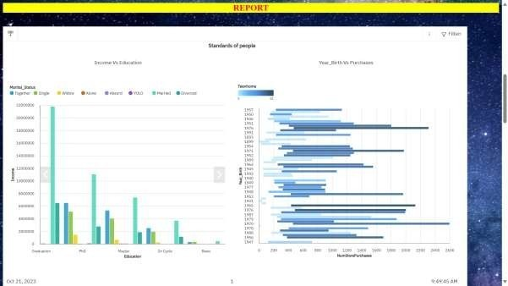

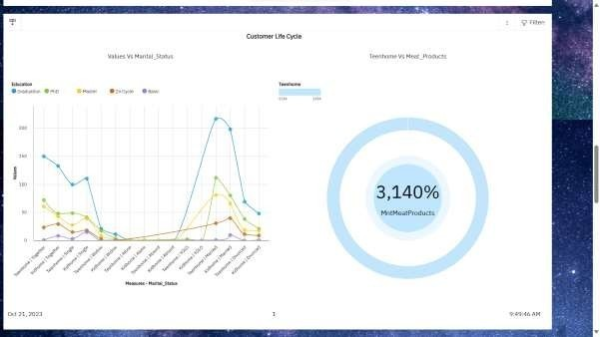

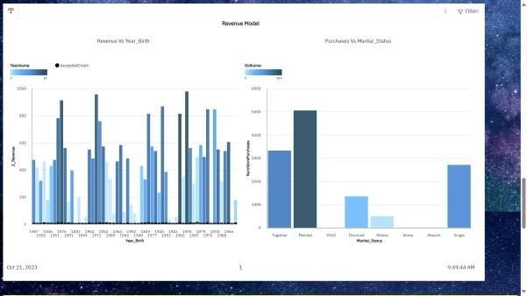

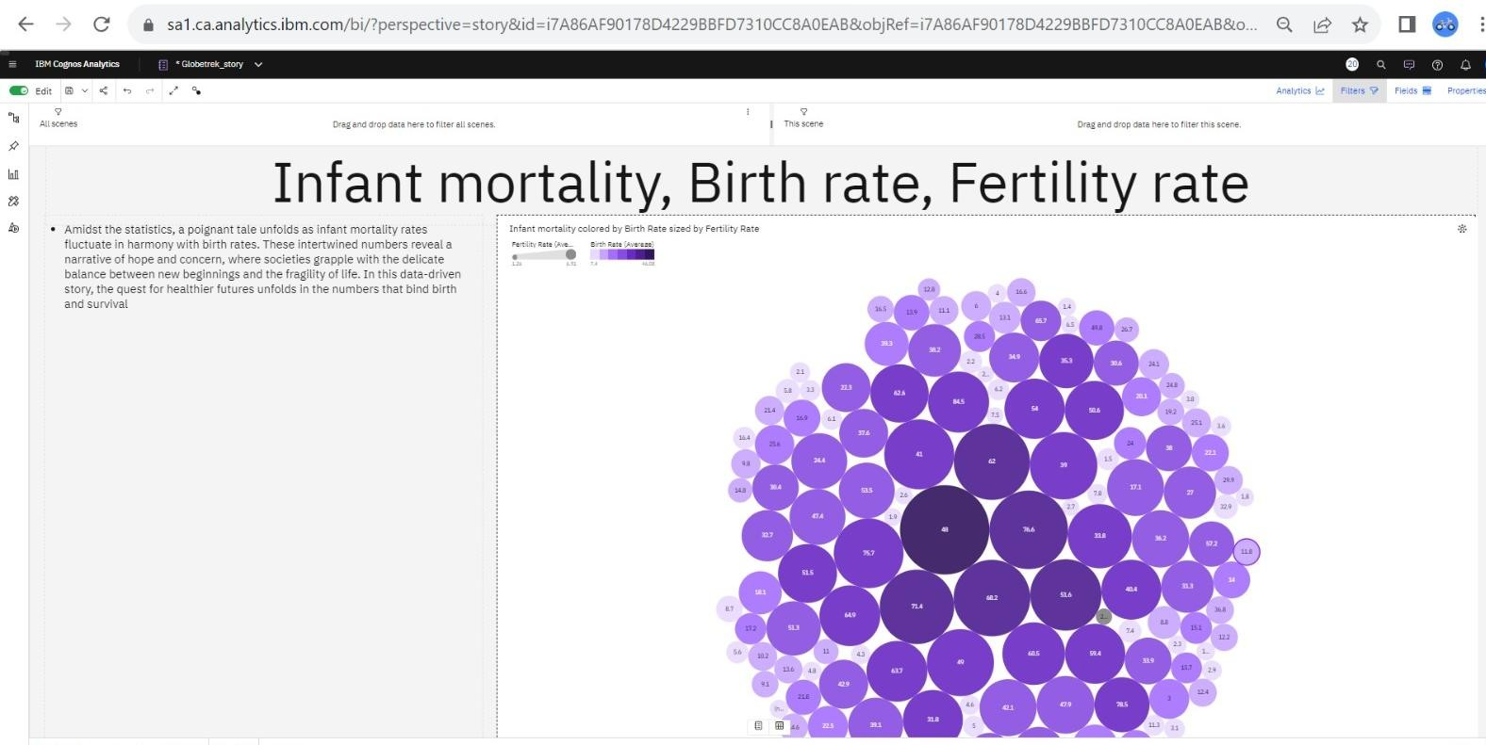



GITHUBLINK:



y-Data-With-IBM-Cognos

PROJECTDEMOLINK:

https://youtu.be/6k4CXEHufHA

al-Countr